SLIDE PUZZLE DESIGN DOC
UML Diagram
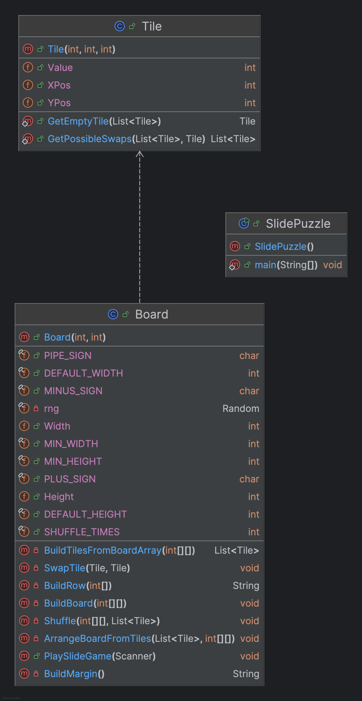
Scalability and Extendibility
This puzzle is scalable because you can adjust the width and the height of the board to be whatever height the user enters. There is a minimum height and width of 2. If the user enters a below the minimum height or width of 2, my program sets the height or width to a default value which is 3 for both of them. It also would write a friendly message to the console saying there was an invalid value for height or width and it’s setting the value to the default.
The puzzle is also extendable because many games will have a board that has a height, width and playGame method. This means if I wanted to extend it, I could have an abstract class with height and width attributes and an abstract playGame method, which takes a Scanner as a parameter for user input, that this game and other games could inherit from. Additionally, many games have tiles which I would need to keep track of a value and it’s x- and y-positions.

